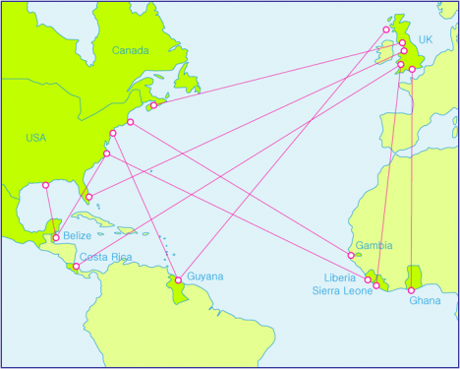

**Partnerships for Home Economics Disaster Assistance to**

**Developing Countries**

**To Whom It May Concern:**

**This receipt acknowledges a donation in the amount of $_________ and/or donated items valued at $____________for our sales tables or other DAP purpose in support of the Disaster Assistance Partnerships Projects for home economics related programs in Developing Countries. Our funds are held in the IFHE-US DAP Special account (501(c)(3) and are therefore tax deductible.**

**Thank you very much for supporting the DAP initiative.**

**Sincerely,**

**Juanita Mendenhall, DAP Coordinator**

[**juanitam@usit.net**](mailto:juanitam@usit.net)

**______________________________________________________________**

**You may itemize your donation below for tax purposes:**